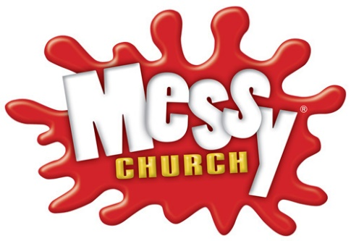
Rayleigh Methodist
Messy Church Newsletter
May 2020

Hello Messy Church Families!
We hope you are keeping well in these challenging times.
We are having our very first YouTube Messy Church on Sunday 31st May, going live on Calvin Samuel’s YouTube channel at our normal time of 4:00 p.m.
We will try to have our normal mix of crafts, puppets, and worship, and we hope you will have your tea afterwards with your family following Messy Church.
One of the crafts will be to make a Pentecost head band. You will need card, glue and crayons to hand.
Another craft will be decorating cakes. The recipe is also in this folder. If you can’t get all the ingredients you could just buy some cupcakes, butter icing and a piping bag and use them instead.
If possible, can you have a balloon ready for Calvin’s talk about the Holy Spirit and a candle so that we can sing Happy Birthday to the church – because Pentecost is really the birthday of the whole church.
We hope that as many people as possible will be able to join in, so please share this news with your friends and families.
So that we can keep in touch, we have set up a WhatsApp group called Messy Church, and people whose mobile phone number we have will already have been invited to join in. We hope you will take photos of what you are getting up to and share it with the group, because we are missing seeing you all. It would be good if you were willing for us to share these on our website.
We already have a Messy Church Facebook so we hope that can be used too. If you see it, please like it!
If you would like to have further details about Messy Church or our other church activities (both while we are dealing with Covid-19 or during ‘normal times’) please do send us a message through the form on the <Contact> dropdown menu. We very much look forward to hearing from you and hearing how you got on with your Messy Church activities.
If, as a church community, we can help you in any other ways, or if you are feeling lonely and would just like a chat, please leave your contact details on a Contact Form and we will promptly get back to you.
Please continue to stay safe in these tough times,
“Our God is a great big God and he holds us in his hands”

Thoughts and prayers,

Pat Norman

