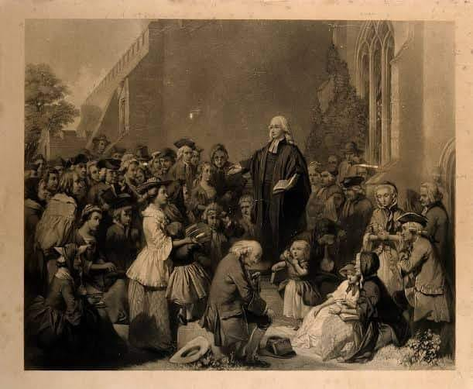
If you have concerns about what our church will look like when we come out of our episode of social isolation, then take John Wesley’s words to heart.
What are we going to make our church look like?
"My fear is not that our great movement, known as the Methodists, will eventually cease to exist or one day die from the earth. My fear is that our people will become content to live without the fire, the power, the excitement, the supernatural element that makes us great."
- John Wesley

