Matt and Savanna Shaw

The Inspirational Father

and Daughter Duo
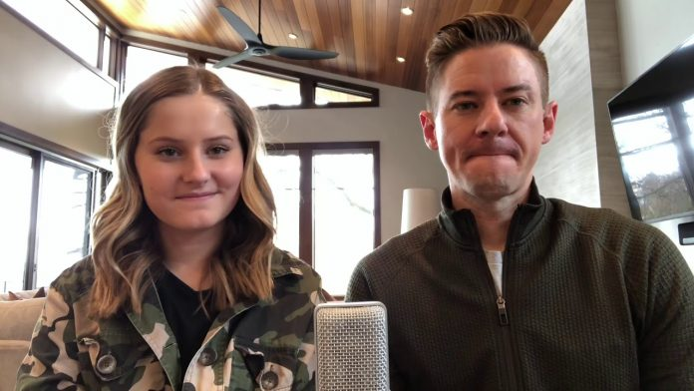 Matt Shaw (father) and Savanna Shaw (daughter), from Kaysville, Utah started recording music videos of themselves singing and harmonising as a way to entertain their family, friends, and of course, themselves. When they recorded “The Prayer” in their kitchen towards the end of February, they had no idea they were creating a four-minute video that would go viral.
Savanna Shaw is a singer in a choir but has recently had practice cancelled due to the Coronavirus pandemic. During her and her family’s isolation, the 15-year-old and her father decided to showcase their musical passion and record a video of themselves performing and upload it to YouTube. Savanna didn’t even have any social media accounts before uploading this video, she joined so she could keep in touch with her friends during the pandemic.
“The Prayer”, which is the first video the family duo ever uploaded, has amassed over 2 million views on YouTube and 4.5 million views on Facebook. In light of all the success their video has had on social media, news companies and music aggregators across the world are now reporting on the beautiful vocals of this father-daughter duo.
Savanna said, “I’ve looked up to my dad and his singing and what he can do with it, for my whole life. So, it’s been amazing to be able to sing with him.” – Source: The Daily Signal.
The duo have been recording more videos together, showcasing their passionate vocals and natural talent during quarantine. After the success of their first video, the new uploads are going out to hundreds of thousands of new fans across the world. The video below is a cover of the well-known song “True Colours” and it has received nearly 300,000 views in 10 days!
Mat was also very happy to be able to use this time to connect with his daughter and create these beautiful videos. Mat said, “If there has been a silver lining in this coronavirus situation for us, it’s that we do get to spend a whole lot more time together. I have heard that the only thing more contagious than a virus is hope, and so we are just trying to do our small little part in the world to spread a little bit of hope.”
Their message is simple and hopefully, like Mat said, “contagious”. They want to spread hope during these tough economic and social times through their music. The image of a father and daughter singing and creating music together certainly has captured the hearts of a nation, and maybe the world, during these unique times. Everyone at The Music Man supports their message and has been thoroughly entertained by their videos. Hopefully, they will inspire others and breed hope across the world at a time where we all need it most.
The words of their first recorded song are particularly apt with everything that is going on in the world, sometimes its best to pause and remember the simple prayer of a father and daughter for “life to be kind”.

The Prayer – 7th March just hold down Ctrl and click on the title of the song to hear it.
If you would like to listen to other songs as Savanna and Matt record them, just look down this list and Ctrl/click on the titles. I will add to the list as they publish new songs, so keep looking. aThe comments arend enjoy)!

A Million Dreams ~ 9th March
One of my million dreams is to be able to share my music! Thank you for listening and for all the support.
Fly Fly Away-Catch Me If You Can ~ 18th March
How many of you have seen Catch Me If You Can? I haven’t seen the musical, but I saw the movie a few nights ago and decided to learn this song!

True Colours ~ 20th March
I think we all can agree that our world has been unpredictable and crazy lately. But let this song be a reminder that there is always a rainbow after the storm.

Fall on Me ~ 27th March
I chose this song because I feel like it represents my relationship with my dad perfectly. My dad and I have become so much closer these past few weeks because of the opportunity we’ve had to create music together. I’m forever grateful for these memories!

I See the Light-Tangled ~ 30th March
We finally recorded a Disney duet! Anyone who knows me knows that my big dream is to be a Disney Princess! This is definitely one of my favourite Disney songs!

Somewhere Over the Rainbow ~ 4th April
It’s National Find A Rainbow Day! I wanted to take advantage of this opportunity to share with you a classic and all-time favourite song of mine. This song is about hope, and encourages us that one day we’ll be able to move past hard times. Keep the faith, my friends! Smile today!

A Whole New World ~ 6th April
We were so happy so many of you requested this song because it’s always been one we have loved! We had so much fun singing this together! It was hard not to smile the whole time!

You Matter to Me ~ 14th April
Matt says, “My youngest daughter, Pennie Jean, was slowly walking towards my wife today, crying and heartbroken. My wife, Brooke, thought maybe she’d fallen off her bike, but when she asked her what was wrong, she said “I miss my grandma. I just want to be close to her. I wish the quarantine was over.” — The physical distance from our loved ones has been so difficult, even for young children! Grandma matters to Pennie Jean. Our family and our friends matter to us, and we matter to them. But, that’s not where the circle of “people who matter” ends. To our healthcare workers and key workers out there keeping us safe - you matter. Those who are working overtime so shops are able to stay stocked with essential items we need to live - you matter. To the Mums and Dads who are now juggling their normal responsibilities with home-schooling and easing the worried hearts of their children - you matter! There is so much love to be given and received.
Tell somebody they matter to you.

All I Ask of You ~ 17th April
The Phantom of the Opera; an early and enduring favourite musical of ours. We’ve had many requests for this song.
Thank you for giving us a good reason to record it!

Can’t Help Falling in Love ~ 20th April
Savanna wanted to record this for my wife and me. She said it’s a beautiful and classic love song that reminded her of us. We love you Savanna! We will always be grateful to have this recording.

Beauty and the Beast ~ 26th April
Hardship, difficulty, and uncertainty – challenges we all face at some point in our lives. But we learn from them and can emerge better people. As certain as the sun rising in the East. There is BEAUTY in the BEAST.

Questions and Answers with Mat & Savanna ~ 29th April
It was so fun sharing some of our story, and answering your questions! We are so grateful to all of you for your encouragement and support. Thank you all! PS. PennieJ ean is all better. She was sad that she wasn't going to get dessert. (She didn't finish all her dinner)!

Mat Shaw ~ Evermore ~ 29th April
Two years ago, Savanna put this at the top of her Christmas wish list: - Recording of Dad singing Evermore.
My dad passed away when he was 38 (I was 14 at the time). I think it concerned Savanna that we didn’t have any recordings of me singing up to that point (I was 37 at the time). Hold close those you love.

