You are warmly invited to share in our
Christmas

Celebrations!

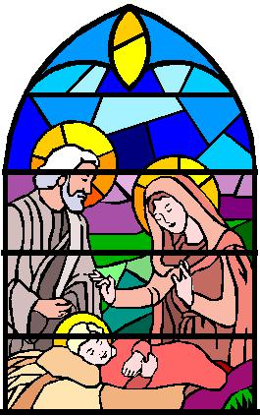
Come and celebrate

Christmas 2019

at Rayleigh Methodist Church

Eastwood Road, Rayleigh SS6 7JP

www.rayleighmethodistchurch.org.uk

Sun |  | 1st Dec | 10:45 – 11:45am | 1st Sunday in Advent – Morning Service
Mon |  | 2nd | 9:30 – 11:00am | Breakfast Club ~ last of the year
 |  |  | 1:15 – 2:45pm | Sunbeams Toddler Group
Sun |  | 8th | 10:45 – 11:45am | Parade Service with Christingle
Mon |  | 9th | 1:15 – 2:45pm | Sunbeams Toddler Group
Sun |  | 15th | 10:45 – 11:45 am | All Age Worship with Holy Communion
 |  |  | 4:00 – 5:30 pm | Carol Service ~ Rev. Dr. Calvin Samuel
Mon |  | 16th | 1:15 – 2:45 pm | Sunbeams Toddler Christmas Party
Sat |  | 21st | see poster for further details | Gospel Choir Christmas Concert
Sun |  | 22nd | 10:45 – 11:45 am | Morning Worship ~ John Phillips
Christmas Eve |  |  | 6:30 – 7:30 pm | Christmas Eve Holy Communion with Remembrance Candle Lighting
Christmas Day |  |  | 9:30 – 10:15 am | Christmas Worship ~ show us a present!  Rev. Dr. Calvin Samuel
Sun | 5th Jan |  | 7:00 – 9:00 am | Live Broadcast of Morning Worship on BBC Radio 4 ~ Rev. Dr. Calvin Samuel
 |  |  | 10:45 – 11:45 am | Annual Covenant Service  Rev. Dr. Calvin Samuel
 |  |  | Please see Church Website for other information

We hope that, over Christmas, you will be able to cope with the stress and strain, contain your excitement, receive some lovely presents, enjoy the company of those around you and also have some time for yourself - to see beyond the glitter and tinsel, beyond Brexit and all the other problems in our world – to reflect on what life is really for.

Do join us for some of our celebrations, you will be very welcome.
Have a very Happy and Peaceful Christmas!

