RAYLEIGH METHODIST CHURCH

Eastwood Road, Rayleigh

Minister
Rev Dr Calvin Samuel M: 07411 289 469
Coordinating Steward
Mrs Pat Norman T: 01268 781896

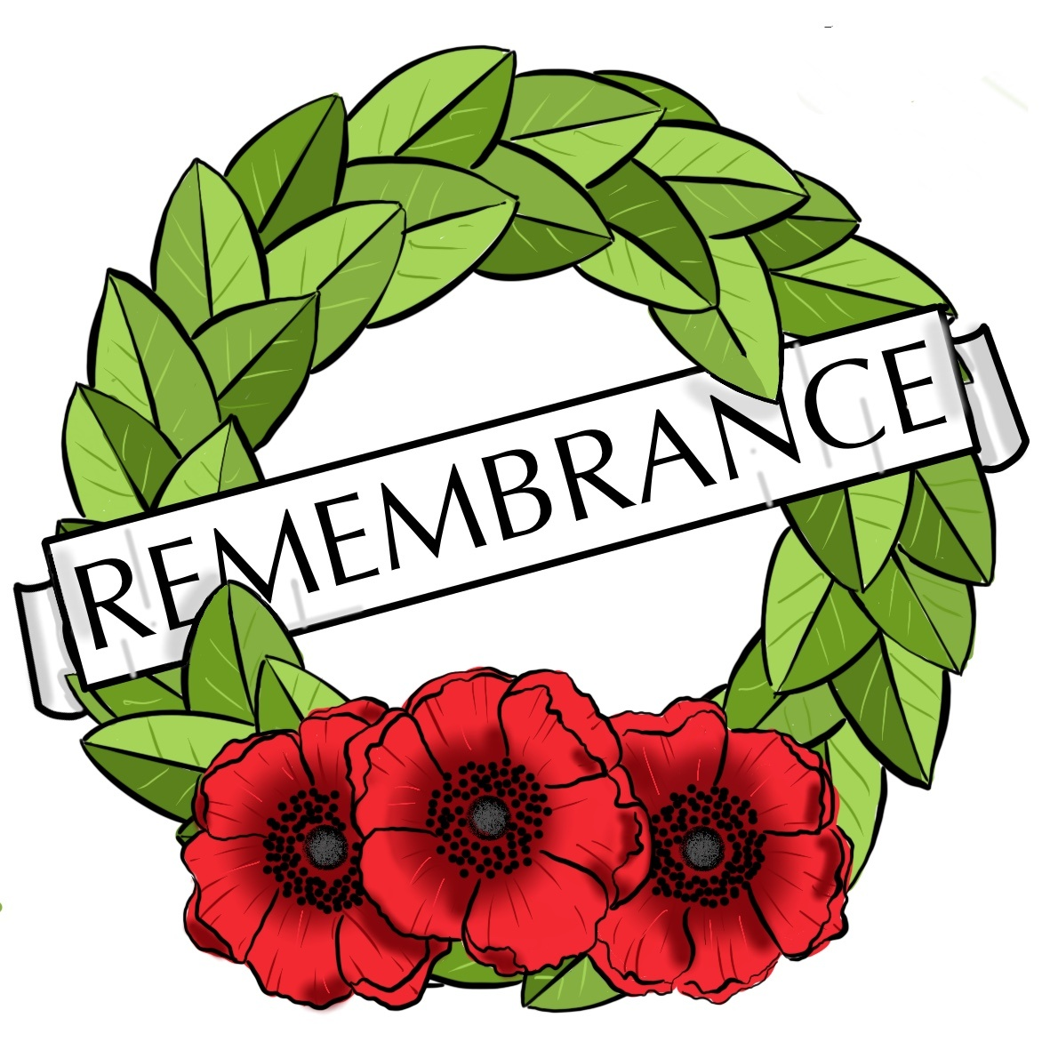

THE NEWSLETTER

NOVEMBER 2019

Experimenting with Change

At the October Church Council we began to engage with the question ‘What kind of Church do we hope to be for Rayleigh?’ There were no earth-shattering insights, no flashes of divine inspiration, and, most disappointingly, no-one started prophesying spontaneously offering a word from the Lord as to the way we should go. I continue to live in hope….

What did emerge was the beginning of a conversation which indicated that of the options presented to us by the short-term nature of my appointment as minister we did not really wish to go for option 1: play it safe. We were more interested in option 2 to explore trying something new, innovative and courageous, something a bit risky, knowing that we have a short amount of time together.

Quite what new things we might explore for the longer term is still to be discerned. For the short term there are some smaller things on the horizon. The first of these will happen in November in our Anniversary Service on 17th November. Rather than a traditional anniversary service which often looks backwards with thanksgiving, we want to use this service to look forwards. So that service will take a rather unusual shape where we want to use our time together to begin to take seriously the idea of doing something new and courageous and innovative.

Please do plan to be with us for the anniversary service on 17th November if you possibly be can. Even more importantly, please do be in prayer for that service that it will be a significant moment for us as a church family. And speaking of family, please don’t forget that the service will be concluded by a family meal at the church from around 1pm onwards.

A second new development in the short term is that the BBC Radio4 Sunday Service will be broadcast from Rayleigh Methodist Church on 5th January 2020. This service has an audience of over 1.5 million people. It will take the form of an abbreviated Covenant Service, given that will be the first Sunday Service of 2020 and in our regular worship that Sunday is commonly Covenant Sunday in many churches across the Connexion.

This BBC Radio4 Sunday Service will be broadcast live from Rayleigh Methodist Church at 08.10 on Sunday 5th January 2020, and will be followed by our own Covenant and Communion Service at 10.45.

The service is intended to give a flavour of the variety of worship and musical styles across the Southend and Leigh Circuit. Music will be provided by our own organist Keith Norman, and a group of musicians from the Fisherman’s Chapel Gospel Vespers Group. Our congregational singing will be supported by choir directed by Heather Simmons, one of our local preachers. I will be assisted in leading the service by the Revd Emma Nash, a Baptist Minister and Evangelist, who is Mission and Community Engagement Officer in the Connexional Evangelism and Growth Team, and a member of our Circuit.

We will need a strong congregation prepared to sing, ideally drawn from across the circuit, to ensure a good sound for the broadcast. So please do plan to be in the service. In order to be ready to broadcast live at 08.10 those who wish to be part of the congregation will need to be seated in church at 07.00 for a warm-up and rehearsal so that we sound as tuneful as possible for the 1.5 million listeners and fellow worshippers.

These are some small developments for the short term. However, there are longer term changes that we will need to experiment with. Bear in mind that experiments do not always work but they always teach us something. So let’s explore together under God what new things we can explore together as we continue to discern what kind of Church we hope to be for Rayleigh.
All God’s Blessings. Calvin.

2

It was:
200 years ago, on 22nd Nov 1819 that George Eliot (pen name of Mary Anne Evans) was born. This British novelist became one of the leading writers of the Victorian era, best known for Adam Bede, The Mill on the Floss, Silas Marner, Middlemarch and Daniel Dronda.
150 years ago, on 17th Nov 1869 that the Suez Canal was officially opened.
Also 150 years ago, on 22nd Nov 1869 that the British clipper ship Cutty Sark was launched in Scotland. It was one of the last tea clippers to be built, and it is now on permanent display at Greenwich in London.
100 years ago, on 11th Nov 1919 that the first Armistice Day (now Remembrance Day) was marked in the UK, after King George V issued a proclamation calling for a two-minute silence at 11:00am on 11th Novmber. The event remembers the members of the armed forces who lost their lives in the line of duty.
60 years ago, on 1st Nov 1959 that the first stretch of the M1 motorway opened in Britain. The first motorway service station (Watford Gap) also opened.
50 years ago, on 16th Nov 1969 that the first episode of the children’s TV series The Clangers was broadcast in the UK. It ran for two series and was revived in 2015.
Also 30 years ago, on 21st Nov 1989 that the televising of proceedings from Britain’s House of Commons began.
25 years ago, on 14th Nov 1994 that the first fare-paying passengers travelled through the Channel Tunnel linking England and France.
Also 25 years ago, on 19th Nov 1994 that the first National Lottery draw was held in Britain.
20 years ago, on 11th Nov 1999 that the House of Lords Act was passed in Britain. It removed the right of hereditary peers to sit in the House. Most members are now life peers.

I would like to thank the church members for the beautiful flowers sent to me from the Harvest Weekend. They really did cheer me up and a week later are still lovely.
Derek Shephard

3

SERVICES FOR NOVEMBER 2019
'3 November | 10.45 | W | Rev Peter Perowne
'10 November | 10.45 | P | Remembrance Sunday  Rev Dr Calvin Samuel
'10 November | 18.30 | RW | Rev Dr Michael Moon
'17 November | 10.45HC | HC CA | Rev Dr Calvin Samuel
'24 November | 10.45 | W | Local Arrangement
'24 November | 16.00 | Messy Church | Local Arrangement
P PARADE HC HOLY COMMUNION W WORSHIP RW REFLECTIVE WORSHIP CA CHURCH ANNIVERSARY

WOMENS FELLOWSHIP
Our programme for November is as follows:

4 November Speaker Sue Howarth Reading
"National Coastal Watch"
11 November Speaker George Lockhart
"Memories in Song"
18 November Speaker Eddie Allen
"Poems Plus"
25 November Speaker Rev. Clifford Newman
"Christmas Quiz"
Elaine Blades

Dear Everyone at Rayleigh Methodist Church, a huge thank you for the beautiful flowers which you gave me following all my hospital tests etc. They certainly cheered me up no end and my favourite colours too. So lovely of you all to think of me.

Many thanks, God's blessings and love and prayers to you all.

Margaret Purves
4
METHODIST CENTRAL HALL WESTMINSTER
Our magnificent building was opened in 1912 to mark the centenary of the death of John Wesley, one of the founders of Methodism. Methodist Central Hall Westminster was one of forty ‘Central Halls’ built at the end of the 19th Century, as part of the Wesleyan Methodist Churches wish to reconnect to the poor of the inner cities. Central Halls were to be a ‘pew on the pavement’ – a place of invitation with little religious symbolism.
Methodist Central Hall Westminster was funded between 1898 and 1908 by the “Wesleyan Methodist Twentieth Century Fund” (or the “Million Guinea Fund”, as it became more commonly known), whose aim was to raise one million guineas from one million Methodists. The fund closed in 1904 having raised 1,024,501 guineas (£1,075,727). Methodist Central Hall Westminster was to act not only as a church, but to be of “great service for conferences on religious, educational, scientific, philanthropic and social questions. In January 1946 the first meeting of the United Nations took place in the Great Hall. Over 50 nations were invited to war-torn London and our building, (which suffered no damage during the war) was chosen. The church moved out to the London Coliseum and the UN were so grateful that they painted the building and left their original ‘minute’ book as a gift! The first Sectary General Trygve Lie was elected and gave his inaugural address in the Great Hall. Methodist Central Hall Westminster has kept close ties with the United Nations, celebrating the organisations 50th, 60th and 70th anniversaries and welcoming the previous three Sectary Generals during their tenure, (Boutros Boutros-Ghali, Kofi Annan, Ban Ki-Moon) and hosting the current UN Sectary General, António Guterres for his first address outside New York in May 2017.
In 1966 the World Cup was stolen from our Library and countless other events have taken place including many speakers of historic note. Sir Winston Churchill, Gandhi & Revd Dr Martin Luther King have all spoken in the building, which continues to be used for conference and events throughout the week.
Today, we have more nations represented in our church membership than the United Nations had in their first meeting! We gather on Sunday at 11am and 6pm for services, and for other events throughout the week. A great place to keep up to date with Methodist Central Hall is through our Social Media channels.
5

THE FALL AND RISE OF METHODISM
Our correspondent asked if anyone could complete the verses of “Ten Little Methodists” (Methodist Recorder, 28 September) which they recited at their Sunday School Anniversary about 50 years ago. Here is one reply.

Ten Little Methodists went to church when fine,
But it started raining then there were nine.

Nine Little Methodists stayed up very late,
One oveslept himself, then there were eight.

Eight Little Methodists on the road to Heaven,
One joined a rambling club, then there were seven.

Seven Little Methodists hear of Sunday 'flicks',
One thought he'd like to go, then there were six.

Six Little Methodists kept their faith alive,
One bought a TV, then there were five.

Fuve Little Methodists seemed loyal to the core,
The minister upset one, then there were four.

Four Little Methodists argued heatedly,
Over forms of worship, then there were three.

Three Little Methodists sang the service through,
God a hymn they didn't know, then there were two.

Two Little Methodists disputed who should run,
The next Harvest Festival, then there was one.

One faithful Methodist , knowing what to do,
Got a friend to come to church, then there were two.

Two sincere Methodists each brought in one more,
So there numbers doubled, then there were four.

6

Four sturdy Methodists simply could couldn't wait,
Till they found four others, then there were eight.

Eight eager Methodists, searching round for souls,
Praying, working, witnessing, drew others in by shoals.

Shoals and shoals at evening service, cramming every pew,
O God supply this grace and zeal in my own circuit too.

M Stones, Uppingham.

WESLEY GUILD
Our Thursday afternoon sessions are going well with some new people joining us. It is lovely to see them and if any more people are looking for something to do on a Thursday afternoon at 2pm please come and join us.

Our Programme for November is as follows:

7 November Jane Fulford

14 November Members afternoon

21 November Rev Brenda Gutberlet

28 November Meal at The Lodge.

Margaret Flintham

HOLLY
Dear All
As you may or may not know I am running wreath-making classes this year in the church hall and I am on the lookout for greenery. So if you have any spare holly, or a holly tree that could benefit a slight prune, please get in touch with me. Thanking you in advance, Sue Ward (07850879874)
7

RMC
COFFEE MORNING.
16 November 2019 from 10.00 to 12.00
THE BIG SING
(Lorraine Mann)

Refreshments
Plus the following stalls, Crafts, Cards, Books, Bric-a-brac,
and much more

100 YEARS

It was 100 years ago, on 11th November 1919, that the first Armistice Day (now Remembrance Day) was marked in the UK. King George V had issued a proclamation calling for a two-minute silence at 11:00am to remember the members of the armed forces who lost their lives in the line of duty.
The two-minute silence was in fact adopted from a South African idea that had spread from Cape Town through the Commonwealth in 1919. The first minute was dedicated to those who died in the war, and the second to those left behind – families affected by bereavement and other effects of the conflict.
The Cenotaph was erected temporarily in Whitehall for a peace parade for Armistice Day in 1920. After a tremendous nationwide response, it became a permanent structure, and in the following years war memorials were created in other British towns and cities.
In 1939, the two-minute silence of Armistice Day was moved to the nearest Sunday to 11th November, so that it would not conflict with wartime production. This tradition continued after World War II – Remembrance Sunday is still marked with a national service, and by special services in most churches throughout the country and beyond. Americans mark Veterans Day instead.

8

Three sons left home, went out on their own and prospered.
Getting back together, they discussed the gifts
they were able to give their elderly mother.
The first said, "I built a big house for our mother."
The second said, "I sent her a Mercedes with a driver."
The third smiled and said, "I've got you both beat.
You remember how mom enjoyed reading the Bible?
And you know she can't see very well.
So I sent her a remarkable parrot that recites the entire Bible.
,
It took elders in the church 12 years to teach him.
He's one of a kind.
Mama just has to name the chapter and verse, and the parrot recites it."
Soon thereafter, mom sent out her letters of thanks:
"Milton," she wrote one son, "The house you built is so huge. I live in only one room, but I have to clean the whole house."
"Gerald," she wrote to another, "I am too old to travel. I stay most of the time at home, so I rarely use the Mercedes. And the driver is so rude!"
"Dearest Donald," she wrote to her third son,
"You have the good sense to know what your mother likes.
The chicken was delicious!"
9

The amount raised at the Women's Fellowship Coffee Morning on October 19th was £266.15, half of which will be given to Church funds. Thank you to all who supported the event.

OPERATION CHRISTMAS CHILD

Christmas is coming and it’s Shoebox time again. Will you join us again to bring great joy to many more children in need, who have yet to receive a shoebox gift?
Boxes to fill and leaflets will be available soon. If you would rather donate filler items for others to use, e.g. Pens, pencils, paper, small toys, toothbrushes, but NO toothpaste or sweets now (new regulations!!) please give them to me to take to the Warehouse.
The Warehouse will be open, from 10am, for checking and packing boxes each Monday, Tuesday, Friday and Saturday from Nov. 11th to 30th. If you would like to help at the Warehouse please see me, and I will let the organisers, Peter and Diane Nicholson, know.
One story from last year…In Guyana, 5 boys were desperate to start a football team but had no equipment. When they opened their shoeboxes they were delighted to find that each of them had received their very own football and pump!

Dilys Hand.

THE LADIES CLUB
6 November Dutch Cottage - 1.45pm - 3.15pm
13 November Karen - Keeping active in later life
20 November Louise Cummings 'Dem bones dem bones' 1.30pm start
27 November Muscular Dystrophy
4 December Christmas lunch
11 December Carol Service

Elizabeth Ellis
10

A HYMN FOR REMEMBRANCE SUNDAY

"Eternal Father, Strong to Save" is a British hymn traditionally associated with seafarers, particularly in the maritime armed services. Written in 1860, its author William Whiting was inspired by the dangers of the sea described in Psalm 107. It was popularised by the Royal Navy and the United States Navy in the late 19th century, and variations of it were soon adopted by many branches of the armed services in the United Kingdom and the United States. Services who have adapted the hymn include the Royal Marines, Royal Air Force, the British Army, the US Coast Guard and the US Marine Corps, as well as the navies of many Commonwealth realms. Accordingly, it is known by many names, variously referred to as the Hymn of Her Majesty's Armed Forces, the Royal Navy Hymn, the United States Navy Hymn (or just The Navy Hymn), and sometimes by the last line of its first verse, "For Those in Peril on the Sea". The hymn has a long tradition in civilian maritime contexts as well, being regularly invoked by ship's chaplains and sung during services on ocean crossings.

The original hymn was written in 1860 by William Whiting, an Anglican churchman from Winchester, United Kingdom. Whiting grew up near the ocean on the coasts of England, and at the age of thirty-five had felt his life spared by God when a violent storm nearly claimed the ship he was travelling on, instilling a belief in God's command over the rage and calm of the sea. As headmaster of the Winchester College Choristers' School some years later, he was approached by a student about to travel to the United States, who confided in Whiting an overwhelming fear of the ocean voyage. Whiting shared his experiences of the ocean and wrote the hymn to "anchor his faith". In writing it, Whiting is generally thought to have been inspired by Psalm 107, which describes the power and fury of the seas in great detail:
Some went out on the sea in ships; they were merchants on the mighty waters.
They saw the works of the Lord, his wonderful deeds in the deep.
For he spoke and stirred up a tempest that lifted high the waves.
They mounted up to the heavens and went down to the depths; in their peril their courage melted away. Psalm 107: 23–26

The first verse refers to God the Father forbidding the waters to flood the earth as described in Psalm 104. The second verse refers to Jesus' miracles of stilling a storm and walking on the waters of the Sea of Galilee. The third verse references the Holy Spirit's role in the creation of the earth in the Book of Genesis, while the final verse is a reference to Psalm 107.

11

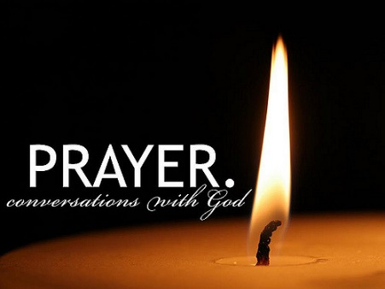

RAYLEIGH METHODIST CHURCH
PRAYER GROUP MEETING DATES
2019

November: 6th & 20th.
December: 4th.

ALL MEETINGS ARE IN THE WELCOME AREA, COMMENCING AT 9.30AM, FOR ABOUT 45 MINUTES.

FROM THE EDITORS WE NEED YOUR ARTICLES for the COMBINED DECEMBER 2019 JANUARY 2020 EDITION
The deadline for the submission of articles for this edition of the Newsletter is Sunday 10 NOVEMBER( in Welcome Area) or Wednesday 13 NOVEMBER by post or email.
johnward816@gmail.com

Bible Study at Clifford and Linda's house at 10am on Friday 29th November - Subject Faithfulness

12
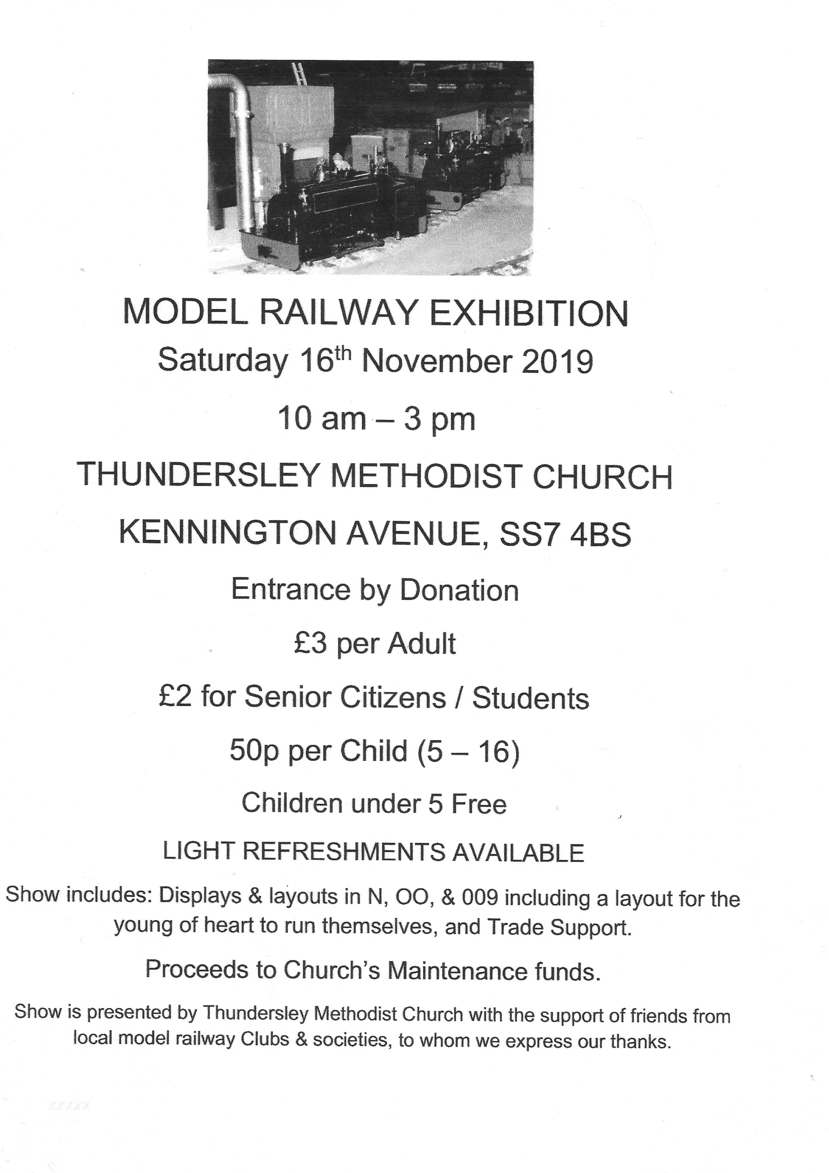
13

SERVICES
Sunday Services 10:45 am and (6:30 pm 2nd and 4th Sunday)
Junior Church 10:45 am
Mid-Week Communion
With the exception of August it is held on the third Tuesday of each month in the WESLEY ROOM at 10:30 am.

REGULAR WEEKLY MEETINGS
Monday
1:15pm Sunbeams Parent and Toddler Group
2:30 pm Women's Fellowship
Tuesday

Wednesday
1:45pm – 3:15pm Ladies Club
4:15 pm-5:30 pm Rainbows
5:45 pm -7:15 pm Brownie Guides
7:00 pm-8.45pm Guides

Thursday
10:00 am Care and Share
2:00 pm Wesley Guild (Sept to May only)
5.15 pm- 6.15pm Beavers
6:30 pm - 7:45 pm Cubs
8:00 pm – 9:30pm Scouts

Friday
4:30 pm-5:45 pm Rainbows
5:30 pm-7:00 pm Brownie Guides
7:15 pm -9:00 pm Guides
7:15 pm -9:00 pm Guides Senior Section (fortnightly)
Preschool
Mon 9:15 am to 11:45 am
Tues Weds Thurs Friday 9:15-11:45 am and 12:30-3:00 pm

Editors John and Sue Ward 9 Sheridan Close Rayleigh SS6 8YR Telephone 01268 742847 (johnward816@gmail.com)

