RAYLEIGH METHODIST CHURCH
Eastwood Road
Rayleigh
Minister
Rev. Stephen Watts 01268 770333
Coordinating Steward
Mrs Pat Norman 01268 781896

THE NEWSLETTER
NOVEMBER 2018

Dear All,

As part of my newsletter article this month I have been asked to feed back information on the ‘Awayday” which recently took place.
For those of you who were unable to attend it can be difficult not feeling to be part of any new process or revelations. Well, there was nothing which took place that would be considered ‘breaking news’, most of the topics on people’s minds seem to reflect on the many different aspects of church life and work. Some were concerned on practical matters whilst others were more into the spiritual side of things. Time together was quite short and I tried to make sure we made the best of that time.

Initially my own personal plans of how the day should go, did not come to fruition as I intended that we would sit together in a large circle, establishing common ground so to speak. Unfortunately due to time and the initial positioning of the church furniture, we ended up with the usual church seating arrangement although slightly banana shaped, myself at the front facing about three rows of participants. Although people may not have been aware of this being not ideal from my point of view, I found it disconcerting and when questions were put my way regarding things I felt a responsibility for, the set up for me was not ideal and at times, rightly or wrongly I felt the weight of blame.

However, that to one side, it seems that people found the day useful, in a location extremely pleasant away from our own environment. Full details of the day will be published for all to see and hopefully comment further on.

There are things which can be put right fairly quickly, there are other matters which we as a community will have to work hard on and it is possible that some things will not be achieved.

1

There is not enough room for me to go into too much detail but our worship styles came under discussion, youth was very much on the agenda together with the lack of takers for posts in the church which need to be filled.

I guess that most of you will be interested to see how I move it forward and I can honestly say there will be changes on my part over which I have influence. The main changes will be around the end of this year when I shall relinquish the property role I temporarily hold by which time it is hoped that someone will be able to take it on board. From the start of 2019 I shall start a bible study and also encourage more house groups to be formed.

Finally, a few thoughts from myself. Often days and meetings such as this can turn into a battle of sorts and the minister can be seen crawling away licking his wounds! For me this was not the case and although there were matters which need looking at which fall directly into my lap, the day was useful for both myself and Valerie. It is fair to say, that digesting what was discussed we have had a number of our own discussions especially on our role.

The past twelve months have been a trial both mentally and physically for obvious reasons, and I shall continue to monitor my mobility or lack of it, how I do my role and how my situation affects others. I am very aware of the limitations which are placed upon me. We are grateful for the support you give us and pray it will continue for the time that we are with you. For those of you who ask if I am getting better, the answer is, I am not sure. Some times I have feelings and pain which may indicate changes in my body but I cannot be sure. What I am doing on a practical note is trying to get into a better shape physically which is no bad thing.

Every Blessing
Steve

2
THE FALL AND RISE OF METHODISM
Our correspondent asked if anyone could complete the verses of “Ten Little Methodists”(Recorder, 28 September) which they recited at their Sunday School Anniversary about 50 years ago. Here is one reply:

Ten little Methodists went to church when fine,
but then it started raining then there were nine.
Nine little Methodists stayed up very late,
One overslept himself then there were eight.
Eight little Methodists on the road to Heaven,
One joined a rambling club then there were seven.
Seven lttle Methodists hear of Sunday 'flicks',
One thought he would like to go then there were six.
Six little Methodists kept the faith alive,
One bought a TV then there were five.
Five little Methodists seemed loyal to the core,
The minister upset one and there were four.
Four little Methodists argued heartedly,
Over forms of worship then there were three.
Three little Methodists sang the service through,
Got a hymn they didn't know then there were two.
Two sincere Methodists disputed who should run,
The next Harvest Social then there was one.
One faithful Methodist knowing what to do,
Got a friend to come to church then there were two.
Two sincere Methodists each brought one more,
So their numbers doubled, then there were four.
Four sturdy Methodists simply couldn't wait,
Til they found four others, then there were eight.
Eight eager Methodists searching round for souls,
Praying, working, witnessing, drew others in by shoals.

Shoals and shoals at every service, cramming every pew,
O God supply this grace and zeal in my own circuit too.

M Stones Uppingham

3

SERVICES For This Month
[S] = Sacrament of Holy Communion [P] = Parade

'04 November | '10.45 | Rev Stephen Watts
 | '18.30 | Circuit Service
'11 November | '10.45 | Rev Stephen Watts [P]
REMEMBRANCE  SUNDAY | '18.30 | Rev Stephen Watts  Reflective Worship
'18 November | '10.45 | Rev Clifford Newman  CHURCH ANNIVERSARY
'25 November | '10.45 | Ms Jill Campbell
 | '16:30 | Rev Stephen Watts  Messy Church

MID-WEEK COMMUNION
There is a mid-week communion in November
Mid-week Communion Sec

Coffee Morning
for
BIG SING SOUL
(Lorraine Mann)
on
Saturday 17 November 2018
10.00 to 12.00 noon

It will include the following stalls, cakes cards, books, bric-a-brac,
and much more
DONATIONS FOR RAFFLE PRIZES WOULD BE APPRECIATED

4
CHURCH FAMILY NEWS
Loving sympathy goes to Andy and Caroline Cameron following the death
of Caroline's father. We hope to see them again soon.
Please remember Les Oatley and Keith Dann as their recovery continues.
Birthday greetings to John Blades, who celebrated his 90th
birthday on October 16th.
Congratulations to Jessica aged 14, granddaughter of Tony and Janet Warner, who was presented with her Gold Chief Scout Award at the Cliffs Pavilion recently. Bravo.
Since Messy Church began a few years ago I have enjoyed helping in the kitchen, working with June and Les Thynne and getting to know the families, but am taking a break and I believe so is Les. I can recommend a pleasant Sunday afternoon in good company and I'm sure June would be pleased to have some help.
Val Tyler

Christian fair-trade business Traidcraft may stop selling goods
Traidcraft plc is in trouble. With very poor recent trading figures and despite enormous efforts by the staff and management and Fair Traders, it warns that the present model for the company may be no longer viable.
Traidcraft’s charity branch, Traidcraft Exchange, will continue to support farmers and lobby government through its charitable arm, and the decision about closing the trading arm is still in a consultation period and not final.
Traidcraft plc first started in 1979, selling fair-trade coffee, sugar and chocolate as well as rugs and handmade baskets from Bangladesh. They went on to sell fair-trade clothes and wine.
Most of us remember them from church stalls and markets. Their aim was to keep a close link between producer and purchaser.
A spokesperson for Traidcraft said: ‘Traidcraft plc’s mission to put the principles of fair trade into commercial practice is not, in any sense, fulfilled but we appreciate that it is time to consider new approaches.’

5
RMC AWAY DAY: OCTOBER 13TH 2018.
It was truly a lovely day weather wise. Bright and sunny to inspire our thought processes!
The venue was amazing. The current building of St Michael’s, Thundersley, is only 6/7 years old, and replaced a WW1 hut which was well beyond its sell by date! So the Congregation saved up and bought a Scandinavian “flat-pack” structure, from Norway, and put it together themselves with some professional help. It is light and airy, with some lovely handmade banners, and coloured glass. It also has a balcony! The facilities are flexible, sustainable, and even after 6/7 years it still has that new wood smell.
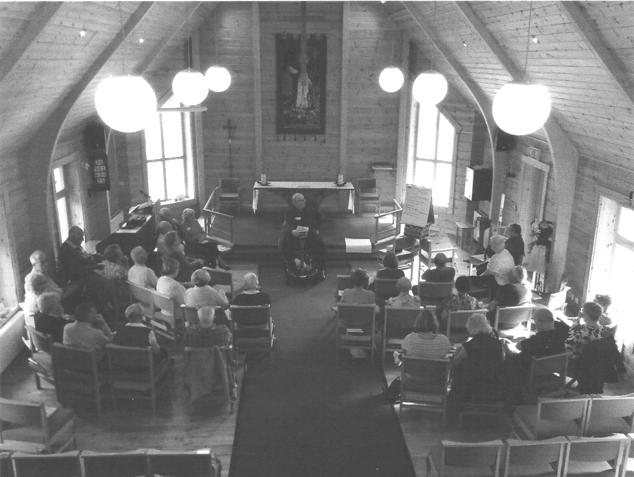
The Church sits in a clearing beside a field and woodland walks, and has a very warm, welcoming feel about it.
There were about 35 of us who gathered together to share our thoughts and feelings about the current situation, and future hopes for Rayleigh Methodist Church.
We were encouraged to speak openly, honestly, but respectfully. If anyone stepped out of line Steve threatened to wave “Peppa Pig” at them!
The four areas covered through general and group discussions were: Worship; Learning and Caring; Service ; Evangelism.
The Stewards have prepared a leaflet comprehensively setting out the many ideas, suggestions, and criticisms put forward. If you haven’t seen a copy please speak to Pat Norman. If you weren’t able to join us at the Away Day

6

and have some additional thoughts and/or suggestions, please let the Stewards or our Minister know.
The ideas and comments were very wide ranging, from re-arranging and re-organising the Church furniture etc., to developing House groups and alternative services. Involving the young people who meet on our premises, to supporting the lonely and housebound.
It is important that we focus on positives as well as negatives. Summer Sunbeams, Breakfast Club and Messy Church, have been successes.
We also need to nurture and encourage the young families who come along week by week.
So many “jobs” in the Church don’t need to be done by Members or office holders. Spread the load, share the work, and involve others. Make them feel part of the service.
My concern is that this exercise will be thrown into touch, like so many others over the last 20 plus years.
If we want our Church to survive and serve God’s kingdom here on earth, then ACTIONS will speak louder than WORDS.
There does seem to be a genuine will to want to move forward. Hopefully we can meet again in maybe 6 months, to review our progress towards some of these goals.
GOD must be at the centre and heart of all we do. Please PRAY for the future of our Church!
Thanks go to Valerie Watts for organising the refreshments.
Janet Warner.

WINTER TRAVEL

A Government warning said that anyone travelling in icy conditions should take

a shovel, blankets, sleeping bag, scarf, hat and gloves
24 hours supply of food and drink
deicer, rock salt, torch and spare batteries
road flares, reflective triangles, tow rope, a five gallon petrol can
first aid kit and jump leads.
So ….. I looked a complete idiot on the bus this morning!

7

LADIES CLUB
Our Programme for the following weeks is as follows:

7 November Rev Stephen Watts
14 November Craft Afternoon
21 November Brian Carline
28 November Electric Bill
31 October Macmillan Coffee Afternoon
Elizabeth Ellis

WOMEN'S FELLOWSHIP
Our programme for November is as follows:
5 November Speaker Roger Smith
"Essex Air Ambulance"
12 November Speaker John Harrison
"Travel Talk"
19 November Speaker Rev. Steve Watts
26 November Speaker Don Maclean
"With Handbell Ringers
Elaine Blades

JUNIOR CHURCH
A teacher asked, “Johnny do you think Noah did a lot of fishing when he was on the Ark?”
“No,” said Johnny, “How could he, with just two worms.”

A teacher said to her children. “We have been learning how powerful King and Queens were in Bible times. But there is a Higher Power. Can anyone tell me what it is?” One child blurted out, “Aces!”

8

CHRISTMAS BAZAAR
Rayleigh Methodist Church
1st December 10am -3pm
It will include:
A variety of Stalls including many Crafts.
Food,
Puppets,
Two choirs,
Art display
and
not forgetting Father Christmas.
All are welcome

WESLEY GUILD
Our programme for this month is as follows:
1 November Nigel Payne
My Life in Television
8 November David Stanley
Music Man Project
(7:30 pm Start)
15 November Keith Leedham
Remembrance Service
22 November Meal at the Lodge

29 November Diane Nicholson
Our Creator's Creation
(7:30 pm Start)
Margaret Flintham
9
THEY SHALL GROW NOT OLD

They shall grow not old as we that are left grow old: age shall not weary them, nor the years condemn. At the going down of the sun and in the morning, we will remember them.
About 20 years ago I had been to the local war memorial on Remembrance Sunday and had been thinking about the names which had been read out. Our memorial just lists names and initials. So, I set out to discover more information about these men.
There are other memorials in the village including a roll of names in the church porch and these had more detail such as which unit the men served in. I published an appeal for information and people came forward with photographs, memories and letters. I also read local newspapers and found articles on the village and notices about the men.

The Commonwealth Graves Commission has a lot of information on the casualties. I searched under the name of the local village. Sometimes it was difficult, as some surnames are commoner than others. In those days you had to pay a fee and send a request by letter but now the database is simple to use online.
Some of the local men had emigrated to the Empire before the war and had enlisted there. The war records held in Canada, Australia and New Zealand are much better preserved and accessible than in this country.
I enjoyed visiting people who proudly showed off their family treasures of medals, letters and memories. 20 years ago, there were people who remembered casualties from the Second World War and even someone who recalled a man who had been gassed in the First World War. A special shed was built for him, which rotated so he had access to fresh air.

What was special for me was putting first names to men only known previously by an initial and then guessing they were known as Bill or Fred rather than William or Frederick.
In the time leading up to Remembrance Sunday why not visit your local memorial? If it is well looked after and free of litter and weeds, then why not write to whoever looks after it and thank them? If not, then find out who is responsible and ask some questions.

10
CHRISTMAS BAZAAR
At the Christmas Bazaar on December 1st we will be serving refreshments – tea, coffee etc. and a selection of cakes and savouries and I’m hoping that some of you will be willing to donate some of the eatables.
At lunchtime we will also be serving soup with a roll or a hotdog. If you would like a lunch please sign the list you will find in the Welcome Area indicating your preference.
As the “Café” will be open from 10 a.m. to 3 p.m. I will need quite a lot of help. If you feel able to spend an hour in the kitchen would you please let me know.
Thank you, Margaret Babbage

WHY IS IT THAT STARS TWINKLE

Why is it that stars twinkle
Why do they wink and shine
The learned men have theories
And so do I have mine
Mine is what my parents told me
When I was just a lad
And when I think about it
It cheers me up when I'm sad
They said, “Somewhere there is a heaven
You can't see it but it's there
It's a place of peace and comfort
For those who love and care
And one day if we get there
We'll try to find a way
To let you know we've made it
And help guide you on your way.”
So when I gaze up on a starry night
The twinkling makes me glad
Now, you can believe the scientists
But I believe my mum and dad.
Eddie Allen
11

PRAYER GROUP MEETING DATES 2018

NOVEMBER: 14th & 28th
DECEMBER: 12th
ALL MEETINGS ARE IN THE WELCOME AREA, COMMENCING AT 9.30AM, FOR ABOUT 45 MINUTES.

FROM THE EDITORS WE NEED YOUR ARTICLES for the DECEMBER 2018/ JANUARY 2019 EDITION
The deadline for the submission of articles for this edition of the Newsletter is Sunday 11 NOVEMBER 2018 ( in Welcome Area) or Wednesday 14 NOVEMBER by post or email. John and Sue
johnward816@gmail.com

Bible Study at Clifford and Linda's house at 10am on 30 November 2018.

12
SERVICES
Sunday Services 10:45 am and (6:30 pm 2nd and 4th Sunday)
Junior Church 10:45 am
Mid-Week Communion
With the exception of August it is held on the third Tuesday of each month in the WESLEY ROOM at 10:30 am.

REGULAR WEEKLY MEETINGS
Monday
1:15pm Sunbeams Parent and Toddler Group
2:30 pm Women's Fellowship
Tuesday

Wednesday
1:45pm – 3:15pm Ladies Club
4:15 pm-5:30 pm Rainbows
5:45 pm -7:15 pm Brownie Guides
7:00 pm-8.45pm Guides

Thursday
10:00 am Care and Share
5.15 pm- 6.15pm Beavers
6:30 pm - 7:45 pm Cubs
8:00 pm – 9:30pm Scouts
8:00 pm Wesley Guild (Sept to May only)
Friday
4:30 pm-5:45 pm Rainbows
5:30 pm-7:00 pm Brownie Guides
7:15 pm -9:00 pm Guides
7:15 pm -9:00 pm Guides Senior Section (fortnightly)
Preschool
Mon 9:15 am to 11:45 am
Tues Weds Thurs Friday 9:15-11:45 am and 12:30-3:00 pm

Editors John and Sue Ward 9 Sheridan Close Rayleigh SS6 8YR Telephone 01268 742847 (johnward816@gmail.com)

7

