Eastwood Road
Rayleigh
Minister
Rev. Stephen Watts 01268 770333
Coordinating Steward
Mrs Pat Norman 01268 781896

RAYLEIGH METHODIST CHURCH
RAYLEIGH METHODIST

THE NEWSLETTER

DECEMBER 2018 & JANUARY 2019

Dear Friends,

It comes around so fast its like ‘Groundhog Day’ (Google it) And however quickly we get our act together, we are way behind the retail giants. When I was a lad we used to visit Blackpool on a regular basis, often as part of a coach party, and before anybody gets cheeky, I mean a motor coach and not one which needs horses !. Anyway we used to play the game of ‘who can spot the tower’ (Blackpool has a tower modelled on that one in Paris). Its quite flat as you drive into Lancashire from Yorkshire, so you are about 10 miles out when you first spot it. The excitement would build until someone screamed ‘I see it!’ and many of those looking found they were focussed in the wrong direction! .
Its the sort of game you often play when approaching the seaside, it keeps up the anticipation.

How long will it be before we start a similar game in respect of Christmas? It just gets earlier and earlier, who knows, one year it might get so bad it overlaps!

About a month ago, I remember listening to someone at church who was very tired. He had come straight from work to the meeting and for a week he had been preparing the store for Christmas. I have yet to be convinced that this early bird catches the worm. Yes I know that in the bible we are urged to be ready, to be prepared, Oh come on, its one thing to be prepared and another to be bored because you have been waiting too long.

I have a message this Christmas, and its a message for retailers the world over,,,,,give us a break. In these days of technology life is much quicker in its delivery. Do we really need to start the process so early. And whats more, I don’t think it makes an iota of difference to the consumer. Surely we could become less stressed, more laid back with time for each other rather than racing around like headless chickens if we really took the time to consider how much better life would be, not just for those delivering the goods, but for all who are involved in what should be a great part of the year.

1

If you are looking for a traditional message, I guess you might think you are looking in the wrong place, well maybe you are. That message has not altered in it format, content or its outcome in the last two thousand years, and guess what, its not going to. We are the ones putting new twists to it, changing it and trying to bring it up to date so that a modern society can understand it.

Well I do not think we need bother. I think we can credit people with an understanding that the message they want to hear is the original message.

I hope you enjoy Christmas as it is meant to be and that you will welcome the Christ Child into your homes and lives as you always have. In this age of upcycling and recycling, lets recycle this one time and time again. Christmas blessings on you all from myself and my special lady.

Every Blessing
Steve

CHRISTMAS BAZAAR
At the Christmas Bazaar on December 1st we will be serving refreshments – tea, coffee etc. and a selection of cakes and savouries and I’m hoping that some of you will be willing to donate some of the eatables.
At lunchtime we will also be serving soup with a roll or a hotdog. If you would like a lunch please sign the list you will find in the Welcome Area indicating your preference.
As the “Café” will be open from 10 a.m. to 3 p.m. I will need quite a lot of help. If you feel able to spend an hour in the kitchen would you please let me know.
Thank you, Margaret Babbage

2

All in the month of December

200 years ago, on 24th December 1818 that the popular Christmas carol ‘Silent Night’ was performed for the first time, at midnight mass at a parish church in Oberndorf bei Salzburg, Austria. It had been written just a few hours earlier by teacher and church organist Franz Xaver Gruber, to lyrics by priest Joseph Mohr. (The lyrics were actually a poem Mohr had written two years earlier.)
175 years ago, on 19th December 1843 that Charles Dickens’ novella A Christmas Carol was first published.
150 years ago, on 9th December 1868 that Franz Haber, Polish-born German chemist was born. He was winner of the 1918 Nobel Prize for Chemistry for developing synthetic ammonia. He was known as the ‘father of chemical warfare’ for his work on poisonous gases during World War 1.
100 years ago, on 14th December that the historic British general election of 1918 took place. It was the first time that women (over 30) and all men (over 21) were eligible to vote. Lloyd George’s Liberal coalition was re-elected.
75 years ago, on 22nd December 1943 that Beatrix Potter, the children’s writer and illustrator, died. She had created animal characters such as Peter Rabbit, Squirrel Nutkin, Mrs Tiggy-Winkle, Jemima Puddle-Duck and many more.
70 years ago, on 19th December 1948 that the Universal Declaration of Human Rights was adopted by the United Nations General Assembly.
60 years ago, on 5th December 1958 that Britain’s first motorway, the Preston By-Pass, was opened. It is now a part of the M6 motorway.
30 years ago, on 21st December 1988 that a Pan Am jet exploded and crashed onto the Scottish town of Lockerbie, killing 259 passengers and crew and 11 people on the ground. The bomb had been planted by Libyan terrorists.
20 years ago, from 16-19th December that Operation Desert Fox took place. US and British forces launched a major four-day series of sustained air-strikes against Iraq after Iraqi President Saddam Hussein refused to cooperate with UN weapons inspectors.
10 years ago, on 19th December 2008 that during the 2008 Financial Crisis President George W. Bush approved a $17.4 billion loans package to rescue the troubled car manufacturers General Motors and Chrysler.
3

SERVICES For December and January

'2 December | 1045 | Worship | Eileen Simmons
'9 December | 1045 | Holy Communion | Rev Clifford Newman
 | 1830 | Reflective Worship | Rev Stephen Watts
'16 December | 1045 | Nativity | Rev Stephen Watts
'23 December | 1045 | Worship | Rev Stephen Watts
 | 1600 | Carol Service | Rev Stephen Watts
'24 December | 2330 | Holy Communion | Rev Stephen Watts
'25 December | 1000 | Rayleigh and Hockley | Rev Stephen Watts
'6 January | 1045 | Worship | Colin Turner
'13 January | 1045 | Covenant  Holy Communion | Rev Stephen Watts
'20 January | 1045 | Worship | Rev Norman Hooks
'27 January | 1045 | Worship | Sanya Strachan
 | 1600 | Messy Church | Rev Stephen Watts

Coffee Morning
for
Rainbows and Brownies
(Elizabeth Ellis)
on
Saturday 19 January 2019
10.00 to 12.00 noon

It will include the following stalls, cakes cards, books, bric-a-brac,
and much more

4

CHURCH FAMILY NEWS
Keith and Marion Dann are celebrating the birth of a new
greatgranddaughter, Hannah Emilia, born to David and Marta on 7 November. Best wishes to all the family.
Congratulations and good wishes to Laura Mann and Ian Molyneux, who have announced their engagement.
More congratulations to Tony and Janet Warner's daughter-in-law Anne, on achieving a BA Hons in Education Studies and Early Years. Well done Anne.
Please remember to send in news of special anniversaries or
achievements in the coming year. Happy Christmas to everyone,
especially remembering those unable to take an active part in church life these days.

Val Tyler

An Accidental Classic
Did you know that “Joy to the World” was not written as a Christmas carol? In its original form, it had nothing to do with Christmas. It wasn’t even written to be a song.
Isaac Watts was one of the great hymn writers in church history, and I guess nothing shows that better than the fact that he wrote one of his most famous hymns by accident. In 1719, Watts published a book of poems in which each poem was based on a psalm. But rather than just translate the original Old Testament texts, he adjusted them to refer more explicitly to the work of Jesus as it had been revealed in the New Testament.
One of those poems was an adaptation of Psalm 98. Watts interpreted this psalm as a celebration of Jesus’s role as King of both his church and the whole world. More than a century later, the second half of this poem was slightly adapted and set to music to give us what has become one of the most famous of all Christmas carols:
5

GOD'S SPECIAL GIFT

For those of us about to spend Christmas with a new child or grandchild, we will know how very special the arrival of a baby is!
This Christmas we celebrate again God’s gift of Jesus: ‘Thanks be to God for His indescribable gift!’ (2 Corinthians 9:15). What can we say about this baby?

He is God Himself:
The unthinkable has happened: God has become a human being! The eternal, creator God enters the world of time and space, both fully human and fully divine. This divine baby can bring hope to our messy world, because He has fully become part of it. He doesn’t stand apart, but demonstrates a commitment to be with us and on our side in the midst of sin and suffering.

He is human like us:
Jesus fully engaged with the jungle of human experience. By His cross and resurrection, He can release us from the power of wrong, hurt and shame to secure for us a life of love, peace and forgiveness. Remember, the crib and cross are made of the same wood!

He is one with us:
In the coming of Jesus, God doesn’t draw us simply into a cosmic event, but into a relationship. Just as you or I can hold and hug our children and grandchildren, so we have a God who wants to be intimately involved in our lives. As Emmanuel, ‘God is with us’ (Matt 1:23). Therefore, the question is: Are we with Him? Are we ready to make space for Him at the centre of our Christmas Celebrations this year?
‘At Christmas time, when we receive presents we don’t really need, God offers us a gift we cannot do without.’ (J John).

6

DANCING DETAINEES - PHILIPPINES (Julie Flintham)

At the beginning of August, I was approached by Santuario de San Antonio Parish of Makati, Philippines and asked to run a 2-month project to teach dancing. Eager to share my passion for ballroom dancing (Dancesport), I quickly gave a positive response before hearing the full details – to teach 100 PDLs (Person Deprived of Liberty or, as we would more commonly call them, Prisoners) at 2 Philippine City Jails!

The gentleman (RJ Limpo) who asked me to help with this project is the Chairman of the Restorative Justice Ministry from the Church and explained that the last week of October is National Correctional Consciousness Week 2018 (NACOCOW). During that week, it is hoped that the PDLs will compete against each other within their respective Jails in Makati City and Taguig City.
A week later, I found myself walking into Makati City Jail compound for the first time. I noticed a group of men were crouched on the floor, hand-cuffed in pairs and counting numbers one by one – I soon found this to be a regular sight as they were heading off to their court hearings. I was advised that the two jails are temporary holding centres for the accused who are awaiting trials. My students were not convicted criminals. For some, they have been waiting months, even years for their trials and I met one lady who had been inside Makati City Jail for 4 years and another more than that inside Taguig City Jail. With the unrealistic scheduling of 20 to 30 trials per day, it is no wonder many detainees are returned to the cells after a long wait in court only to hear that their trial will be rescheduled for another day (avergage waiting time, another 3 months). The correctional facilities of The Philippines are now amongst the most overcrowded in the world – in Makati, the cells contained 65-70 people per cell and in Taguig the cells, which were designed to house 9 inmates, were actually home for an average of 95 men!
I was escorted around to the area for the dance lessons. We were lucky enough to be able to use their chapel, which was a simple open

7
structure with a roof, but it made an environment where the students had the chance to really focus. In Taguig, however, this was not the case. Getting students to focus was a true challenge on top of teaching dance – the open basketball court with PDL spectators from 5 floors of cells above us was a perfect environment for the students to be distracted. I’m sure for many in both jails, signing up to dance was merely a chance to communicate with friends, relatives and even spouses who they would otherwise not have an opportunity to see. But interestingly, by the end, the dance became the most important thing and I was highly impressed by their concentration especially in the last few weeks.

All of the training days were special, but on one particular morning, something different happened. One of the PDLs, about 20 years old, caught our eye. Just like all of them, he was a beginner but slowly improving as the sessions progressed – but he seemed to have extra focus than previous sessions. The class was at a stage where students were continuously dancing the rumba routine to music. Everyone did well and the room was filled with cheers (and high fives) of praises, congratulations and pride. Then suddenly RJ found this same guy on his chair, trying to catch his breath but with tears rolling down his face. He tried to hide them. But even after wiping them dry 5 times he would still well up. It was apparent that this was coming from the overall feeling of accomplishment and mastery that he just finished. Even if he was not the best dancer in the room, he still tried his best. And that was good enough. Even if just for himself.

The competition days approached and, thanks to donated dance shoes and trips to Divasoria (a local market town), the participants were kitted out with leotards and skirts for the ladies and black competition style tops for the gentlemen. I refer to the dancing detainees as Ladies and Gentlemen, because that is truly what they were on the competition day. I was so happy when a guest commented on how the Ladies were all sitting correctly in their chairs.
8
The gentlemen were standing tall and proud behind the ladies and when it came for their turn on the floor; they held a hand out to invite their partners to dance with them.

Having previously created partnerships, during session 10 we arranged for the students to be divided into 3 groups via a fair process of drawing numbers from a box. Each group then had to vote team captains and enter couples for the 5 events that had been created for the NACOCOW week events. Single Dances for those who had more confidence in a specific style plus 2 and 3 dance events for those who wanted to challenge themselves further.

But, as the parades started, the opening prayers, speeches and declaration of the events being open, it was “showtime” and wow what an atmosphere! The audience loved it, the guests loved it and it was clear that the competing PDLs loved it! What an experience – how they all leveled up. From the sidelines, nothing more any of us who had been on this journey with them could do, except stand and enjoy the moment with extreme pride. The faces just said it all, the dream all PDLs have every day coming true for just those few minutes on the dance floor – freedom.

Many of the PDLs are broken people. They don't feel trusted. During the time spent in jail there are often times that reminds them they cannot be trusted and sometimes they can't even trust themselves anymore. Programs such as the Dancesports for PDLs is without a doubt, a surefire way to restore this trust in themselves. To give them a sense of achievement, purpose, joy, distraction from misery, connection to others and adherence to instruction to name a few. Our goal was for them to compete at the end of the training, but we achieved so much more than that.

What a project, what a challenge, what an opportunity, what a great team working together to create an all-round great experience!

9

WAS JESUS REALLY BORN ON 25 DECEMBER

Almost certainly not. But the story of how that date came to be chosen as His ‘birthday’ is one that stretches back long before His birth.

It seems to have started on the Greek island of Rhodes in 283 BC. That year the solstice fell on 25th December, and it was also the year that the Ancient World’s largest Sun God stature – the 34 metre, 200 tonne Colossus of Rhodes, was consecrated.
By 46 BC, Julius Caesar had made 25th December the official winter solstice.

In AD 274, the Roman Emperer Aureilian chose the winter solstice to be the birthday of the Sun God. He also decreed that Sol Invictus (the unconquered sun) was ‘Lord of the Roman Empire’.

Fifty years after that, and Constantine had become the first pro-Christian Roman Emperor. He wanted the Church to celebrate the birth of Jesus Christ on 25thDecember. Perhaps it was that to him, Jesus was more or less the same person as the mighty Sun God. Or perhaps he felt that the ancient sun god’s association with goodness, light, warmth and life would help ease the people’s transition from paganism to Christianity. Whatever the reason, the Church went along with it, and chose 25th December to be the date of Christmas. And in an ancient mosaic in the crypt of St Peter’s Cathedral, Jesus is portrayed as adorned with sun rays and riding in a chariot – just like Sol Invictus.

As for the huge, bronze 200 tonne Sol Invictus? He fell over during an earthquake and was sold off for scrap metal in 654AD by an enterprising Arab scrap merchant. Meanwhile, Jesus lives on…

10

WORDSEARCH
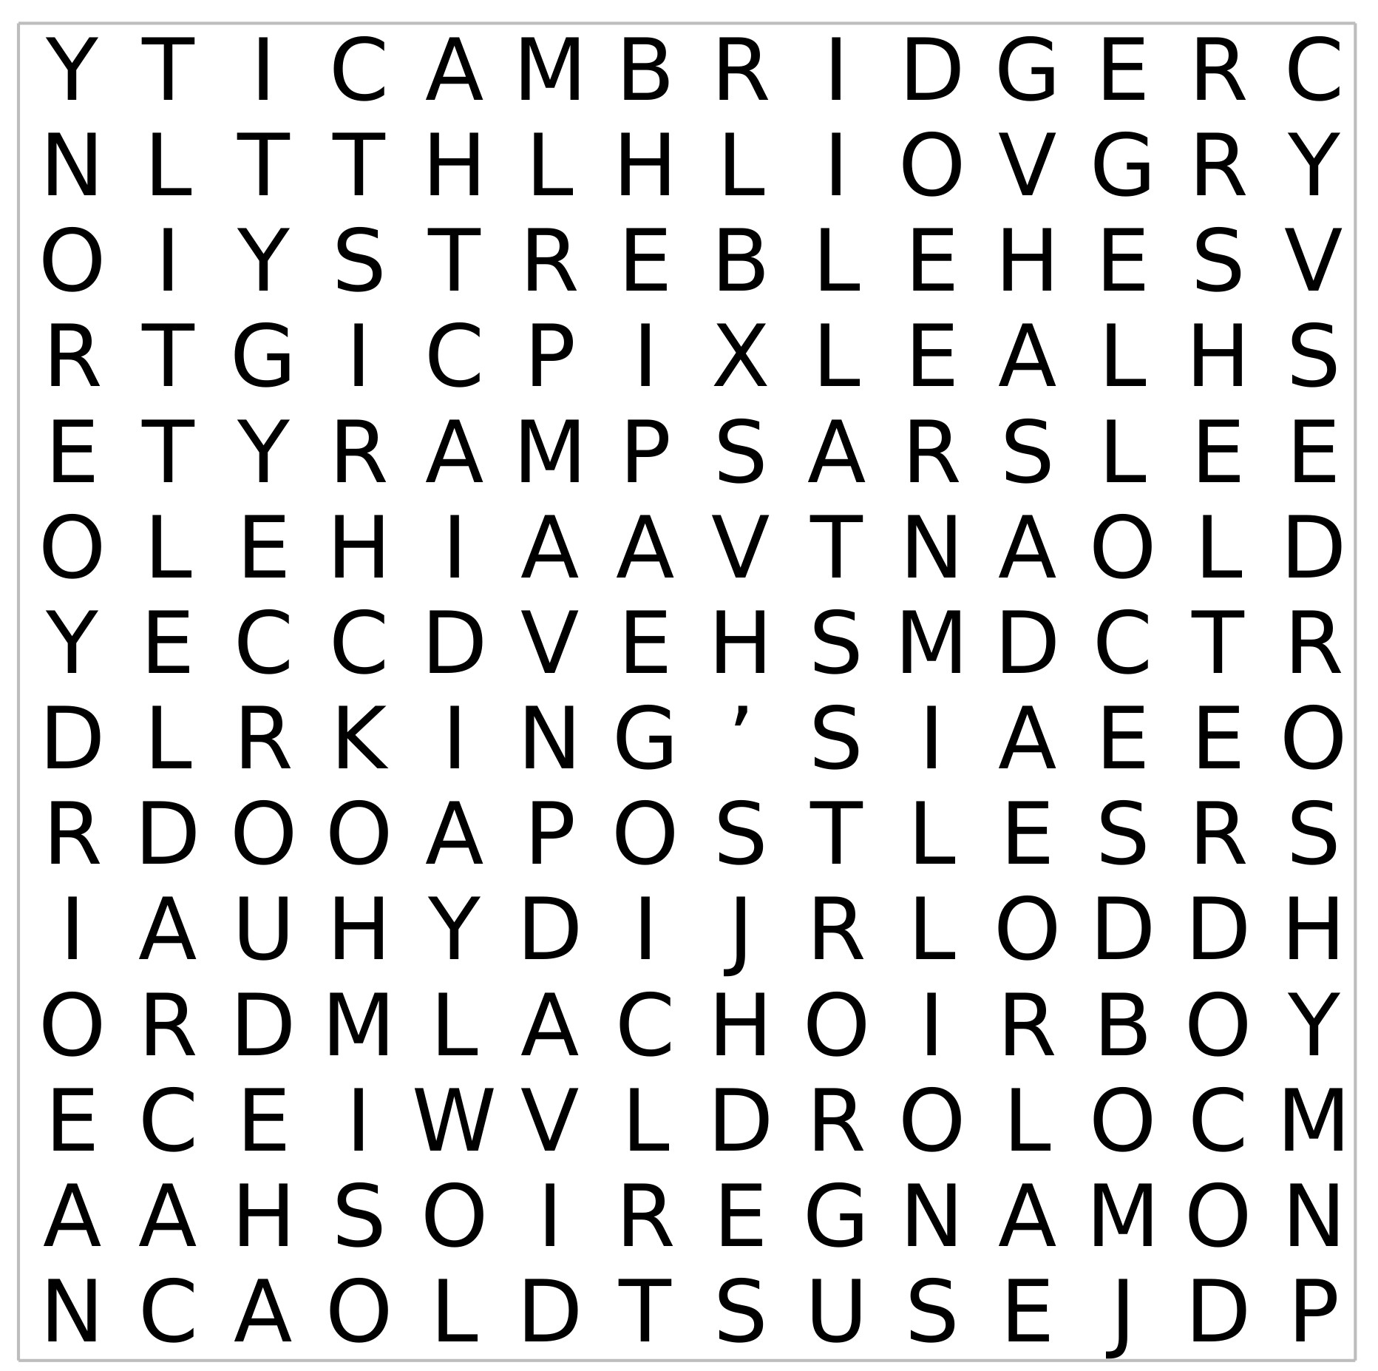

Christmas Millions Radio Eve Treble
Cambridge Choirboy Royal Hymn David
City King’s College Chapel Alexander
Apostles Creed Virgin Mary Jesus
Christ Little Child Earth Heaven
Lord Manger Stall Shelter Cradle
Poor Mean

11

The Coffee Morning for BIG SING SOUL together with donations raised £742.40.
Thank you to everyone who contributed in any way to achieve this fantastic amount.
Lorraine Mann

LADIES CLUB
Our programme for December is as follows:

5 December Christmas Lunch
12 December Carol Service

Our meetings start at 1:45 pm unless otherwise stated.
Elizabeth Ellis

WOMEN'S FELLOWSHIP PROGRAMMES FOR DECEMBER AND JANUARY

2018
3 December Christmas Readings

10 December Christmas Lunch
With Carols 1.00pm Start
2019

7 January Welcome back social afternoon

14 January Speaker Peter Marshland
"When Policemen Had Feet"
21 January Speaker Eve Regelous
"The History of Harrods"
28 January Speaker Doreen Sim
"Guide Dogs"
A very happy and healthy Christmas to all.
Elaine Blades

12
CHRISTMAS BAZAAR
Rayleigh Methodist Church
1st December 10am -3pm
It will include:
A variety of Stalls including many Crafts.
Food,
Puppets,
Two choirs,
Art display
and
not forgetting Father Christmas.
All are welcome

The Methodist Church is appealing for help in helping victims of the Indonesian tsunami.
On Friday 28 September, a 7.5 magnitude earthquake struck just off the central island of Sulawesi in Indonesia, setting off a tsunami that engulfed the city of Palu. Waves more than three metres high swept across the land destroying almost everything in their wake. Many neighbouring towns and villages were cut off by landslides and debris.
All We Can’s Humanitarian Aid Coordinator Laura Cook said: “The final death toll could rise in to the thousands, and thousands more are left in a dire situation. Conditions in the devastated area are extremely difficult. The tsunami tore up roads, washed away homes and cut off lines of communication. At least 42,000 people are displaced and more than 1.5 million have been affected. We urge people to give generously so we are able to respond quickly.” To give, visit www.allwecan.org.uk/indonesia

13

With Christmas in mind….
What do you call a cat in the desert? Sandy Claws.
What goes oh oh oh? Santa walking backwards.
What did the dog get for Christmas? A mobile bone.
Who delivers presents to sharks at Christmas? Santa Jaws.
What did Adam say in the Garden of Eden on December 24? It’s Christmas, Eve.
Why do turkeys never go hungry at Christmas? They’re always stuffed.
Which Christmas carol is most popular with new parents? Silent Night!
Where do mistletoe go to become famous? Holly-wood
Why is turkey so popular at Christmas? Because the weather is a lot warmer over there.
Why do Mummies like Christmas so much? Because of all the wrapping!
What is the best Christmas present in the world? A broken drum – you just can’t beat it!
What’s impossible to overtake at Christmas? – The three wide men!
How do snowmen get around? On their icicles.
What does Santa call reindeer that don’t work? Dinner.
I sent my girlfriend a huge pile of snow. I rang her up and asked, ‘Did you get my drift?’

Learn a poem by heart this Christmas – and stay sharp
So here is a challenge for you: learn a poem, by heart, by Christmas. That is the challenge that Gyles Brandreth, actor and broadcaster has set his grandchildren this year.
Memorising poetry is good for everyone. Brandreth cites scientific research to say that memorising poetry can help keep your brain fit and well.
The Duchess of Cornwall, who recently took over from the Queen as patron of The Royal Society of Literature, admits to reciting poems to herself as she goes to sleep. Dame Judi Dench can still recite the whole of Twelfth Night and A Midsummer Night’s Dream.

14

MUSIC IS MAGIC
ROYAL ALBERT HALL
MONDAY 15th APRIL 2019 - 6.30pm

You may have met David Stanley and been inspired by
his work with “The Music Man Project”. He has staged two concerts at the London Palladium and hopes to fill the Albert Hall next April.

We are trying to organise a coach departing Rayleigh at 4pm.

The cost is maximum £30. Including ticket, coach and drivers tip.

Please let us know if you wish to come with a cheque payable to Mrs P Harrison or cash.

Pat & John Harrison Tel: 01268 774673

Wesley Guild
6 December Margaret Babbage
'Christmas Box'
13 December Diane Nicholson
7:30 pm Start 'Our Creator's Creation'

20 December Carol Service

3 January Coffee Evening
7:30 pm Start at Rene Crompton.
14 Gayleighs, Rayleigh
10 January No Meeting
17 January No Meeting
24 January 'My life in the Police Force'
Martin Oakley
31 January (Flying for Life)
7:30 pm Start Lynne Barker
Margaret Flintham
15

RAYLEIGH METHODIST CHURCH
PRAYER GROUP MEETING DATES

2019
February: 13th & 27th.
March: 13th & 27th. April: 10th & 24th.
May: 8th & 22nd. June: 5th & 19th.
July 3rd & 17th. NO MEETING IN AUGUST.
September: 11th & 25th. October: 9th & 23rd.
November: 6th & 20th. December: 4th.

ALL MEETINGS ARE IN THE WELCOME AREA, COMMENCING AT 9.30AM, FOR ABOUT 45 MINUTES.
FROM THE EDITORS WE NEED YOUR ARTICLES for the FEBRUARY 2019 EDITION
The deadline for the submission of articles for this edition of the Newsletter is Sunday 13 JANUARY 2019( in Welcome Area) or Wednesday 16 JANUARY by post or email. John and Sue
johnward816@gmail.com
Bible Study at Clifford and Linda's house at 10am on 25 January 2019.
16

SERVICES
Sunday Services 10:45 am and (6:30 pm 2nd and 4th Sunday)
Junior Church 10:45 am
Mid-Week Communion
With the exception of August it is held on the third Tuesday of each month in the WESLEY ROOM at 10:30 am.

REGULAR WEEKLY MEETINGS
Monday
1:15pm Sunbeams Parent and Toddler Group
2:30 pm Women's Fellowship
Tuesday

Wednesday
1:45pm – 3:15pm Ladies Club
4:15 pm-5:30 pm Rainbows
5:45 pm -7:15 pm Brownie Guides
7:00 pm-8.45pm Guides

Thursday
10:00 am Care and Share
5.15 pm- 6.15pm Beavers
6:30 pm - 7:45 pm Cubs
8:00 pm – 9:30pm Scouts
8:00 pm Wesley Guild (Sept to May only)
Friday
4:30 pm-5:45 pm Rainbows
5:30 pm-7:00 pm Brownie Guides
7:15 pm -9:00 pm Guides
7:15 pm -9:00 pm Guides Senior Section (fortnightly)
Preschool
Mon 9:15 am to 11:45 am
Tues Weds Thurs Friday 9:15-11:45 am and 12:30-3:00 pm

Editors John and Sue Ward 9 Sheridan Close Rayleigh SS6 8YR Telephone 01268 742847 (johnward816@gmail.com)

9

