RAYLEIGH METHODIST CHURCH
78 Eastwood Road, Rayleigh, SS6 7JP

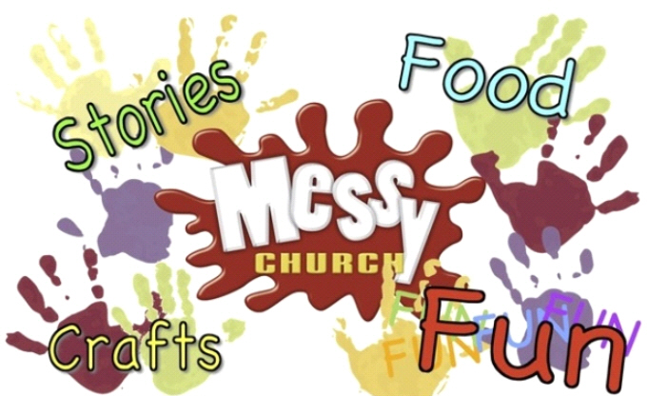

Upcoming Dates
19th October 2014  The story of Joseph | 7th December 2014  The Christmas Story

Messy Sundays take place: 4pm-6pm

Free entry and all are welcome so . . . . . . Come and give us a try!

Messy Church helps people learn more about Jesus. It is for adults and children to enjoy stories together and uses hands-on activities to explore Bible stories, to reflect a God of creativity and to share in play and food (http://www.messychurch.org.uk)

